# **What Is HTTP/2 And How Is It Different From HTTP/1?**

HTTP, HyperText Transfer Protocol, is a synonym to ‘accessing internet’ for most of us. Came into being in 1991, it has been around for quite A long time. The communication protocol – your aid in reaching World Wide Web – needs no introduction today.

While its initial version 1.1 is still the most extensively implemented protocol, it surely has its disadvantages today. That’s what HTTP/2 came into being. This version addresses most of the shortcomings of HTTP v1.1.

In this post, we will define HTTP/2, why it was needed, what are its advantages, why could it be disadvantageous, alongside the key differences between HTTP/2 and HTTP/1.1

## **Development Journey: Advancement from HTTP/1 to HTTP/2**

In 1989, Tim Berners-Lee invented HTTP. HTTP/1.1 was its 1st standardized version that was available for use in the year 1997 for the end-users. This version presented considerable performance optimization over its precursors and changed how communication was handled between clients and servers. However, its key qualities opened the doors to many performance and API security loopholes.

HTTP/1 was known to have poor response time. With websites becoming more resource-intensive, the protocol was losing its efficiency. It progressively became essential to minimize latency and boost page load speeds.

Google looked into these problems. And as expected, SPDY - an experimental project to end troubles with HTTP/1.x – was put into trial in the year 2010.

Years later, the IETF, Google, Microsoft, and Facebook released the fully-comprehensive and well-tested newer version of HTTP in 2015.

HTTP/2, based on SPDY protocol, was developed to address the inherent limitations of HTTP/1.1 and further progress the Internet.

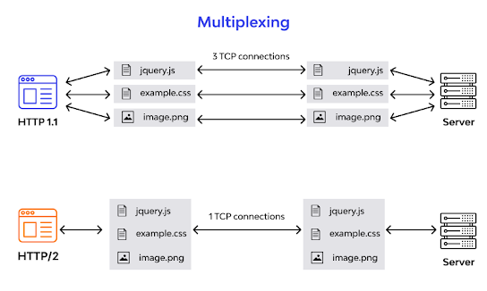

## **What is the HTTP/2 Protocol**

HTTP/2 is the second version of HTTP with most of the shortcomings of its predecessor addressed in it. It has come with advancements in efficiency, speed, and security. Till the date, HTTP/2 is supported on almost all popular web browsers, such as Chrome, Firefox, Internet Explorer, and Safari.

HTTP/2 aims at simplifying, speeding up, and empowering the applications across the internet. To achieve the same, the protocol emphasizes on page load time, resource optimization, and round-trip time (RTT) reduction.

For resource-heavy pages, it supports gradual downloading on the user’s end to improve user experience.

‍

## **HTTP/1.1 and HTTP/2 Main Differences**

Launching of the HTTP/2 was an attempt to overcome the limitations of HTTP/1.1 and make it a more efficient web protocol. So, the major differences in these two are mainly the additions or upgrades applied in HTTP/2. Let’s see what they are:

### **The Background**

For better contextualization of the certain alterations that HTTP/2 made to its precursor, we’ll take a quick look at their basic functionalities and development details first.

**HTTP/1.1**

HTTP protocol was developed in 1989 as the common language that enables client and server machines’ interaction. Process steps are as enlisted:

1. The client (browser) has to send a request to the server using the method (GET/POST).
2. Server responds with the requested resource, for example – image, alongside the status of what it did to the client’s request.

Keep in mind that this is not a one-time process. Such requests and responses needs to be transferred between both these machines until the client receives all the resources, essential to load a web page on the end-user’s (your) screen.

This request-response exchange can be regarded as an IP stack being handled by transfer layer and networking layers before finally reaching to the application layer. Now, let’s see how HTTP/2 handles the same scenario.

**HTTP/2**

HTTP/2 was released at Google as the significant improvement of its predecessor. It was initially modeled after the SPDY protocol and went through significant changes to include features like multiplexing, header compression, and stream prioritization to minimize page load latency. After its release, Google announced that it would not provide support for SPDY in favor of HTTP/2.

The major feature that differentiates HTTP/2 from HTTP/1.1 is the binary framing layer. Unlike HTTP/1.1, HTTP/2 uses a binary framing layer. This layer encapsulates messages – converted to its binary equivalent – while making sure that its HTTP semantics (method details, header information, etc.) remain untamed. This feature of HTTP/2 enables gRPC to use lesser resources.

## **Advantages and Disadvantages of HTTP/2**

Naturally, as the updated technology, HTTP/2 brings its fair share of benefits and drawbacks to the cyber world. Below is the list of the advantages and disadvantages of HTTP/2:

**Advantages:**

* HTTP/2 supports full multiplexing for requests as well as responses over a single TCP connection. Due to these capabilities, lower page load times are achieved by removing needless latency and improving the overall capacity of network alongside its availability.
* Resource usage has increased dramatically for machines processing requests to deliver media-rich content and complex web designs. Developers worked hard around optimization hacks, and as a result, the robust solution of HTTP/2 was obtained. Features, such as server push, stream dependency and prioritizing, header compression, and binary format layer, have improved network utilization as the core advantage.
* The HTTP/2’s ability to transmit more data per client-server communication cycle greatly improves web performance. As a result, increased user satisfaction, better SEO, greater productivity, growing userbase, and improved sales figures can be achieved.
* All modern browsers support HTTP/2 over HTTPS with the SSL certificate installation. To open HTTPS capable invisible proxy ports on every relevant port, OWASP ZAP or its alternatives could be used.
* The use of the HPACK algorithm enables HTTP/2 to overcome the common [API security](https://www.blogger.com/blog/post/edit/8724470710175772304/763042581691480689?hl=en#) threats. This protocol has commands in binary format and compresses the HTTP header metadata to protect sensitive data shared between both machines.

**Disadvantages:**

* While HTTP/2 mitigated the effects of HOL blocking in its predecessor, TCP-level block still causes problems.
* For client machines operating on a slow network, data packets drop bit by bit, and the network quality gets degraded to a single HTTP/2 connection. Due to this, the entire process slows down, thereby blocking a lot of data transfer.
* The cookie security failure is still not addressed in HTTP/2 like its precursor. Cookies are .txt files containing client data obtained by the server and website. However, these cookies may get stolen or tampered with by hackers, who can access personal user data, even without passwords.
* **What is HTTP/3?**HTTP/3 protocol is the latest version of HTTP that will impact the communication between clients and servers, with significant upgrades for user experience, including API security, reliability, and performance. While the HTTP semantics are consistent across all versions, HTTP/3 differs from its precursors due to the mapping of these semantics to underlying transports.  
  Both HTTP/1.1 and HTTP/2 use TCP as their transport, whereas HTTP/3 is based on Google’s QUIC – a transport layer network protocol that implements user space congestion control over UDP (User Datagram Protocol).  
  It has come with many solutions, such as decreased effects of packet loss, zero round-trip time, more comprehensive encryption, and faster connection establishment, to fix HTTP/2’s shortcomings. HTTP/3 will soon be the standard protocol and has already seen a huge roll in libraries, infrastructures, and browsers.
* 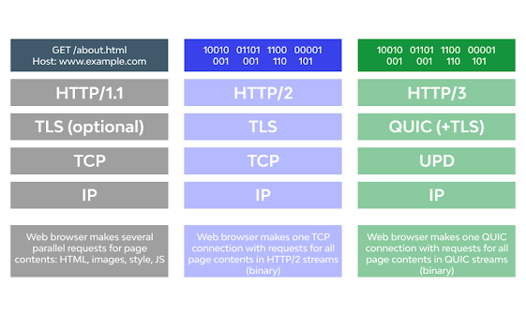
* **Conclusion**The influence and control of HTTP/2 in the cyber world are absolutely inexorable. The core features of HTTP/2 provide greater levels of control that can be used to optimize the web application performance. Certainly, the tech world is rapidly evolving with each passing year, which needs advanced technologies every now and then. HTTP/3 is the upcoming internet protocol developed to fix the shortcomings of its predecessor. However, there is so much left to do, and HTTP/2 is not going away any time soon.